How to create a fillable PDF form on Adobe Acrobat DC

1. Within Acrobat, click on the Tools tab and select Prepare Form.

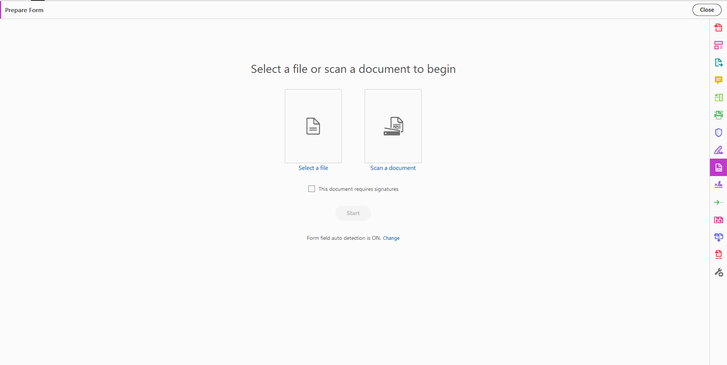

1. Select a file or scan a document. Acrobat analyzes your document and adds form fields automatically.

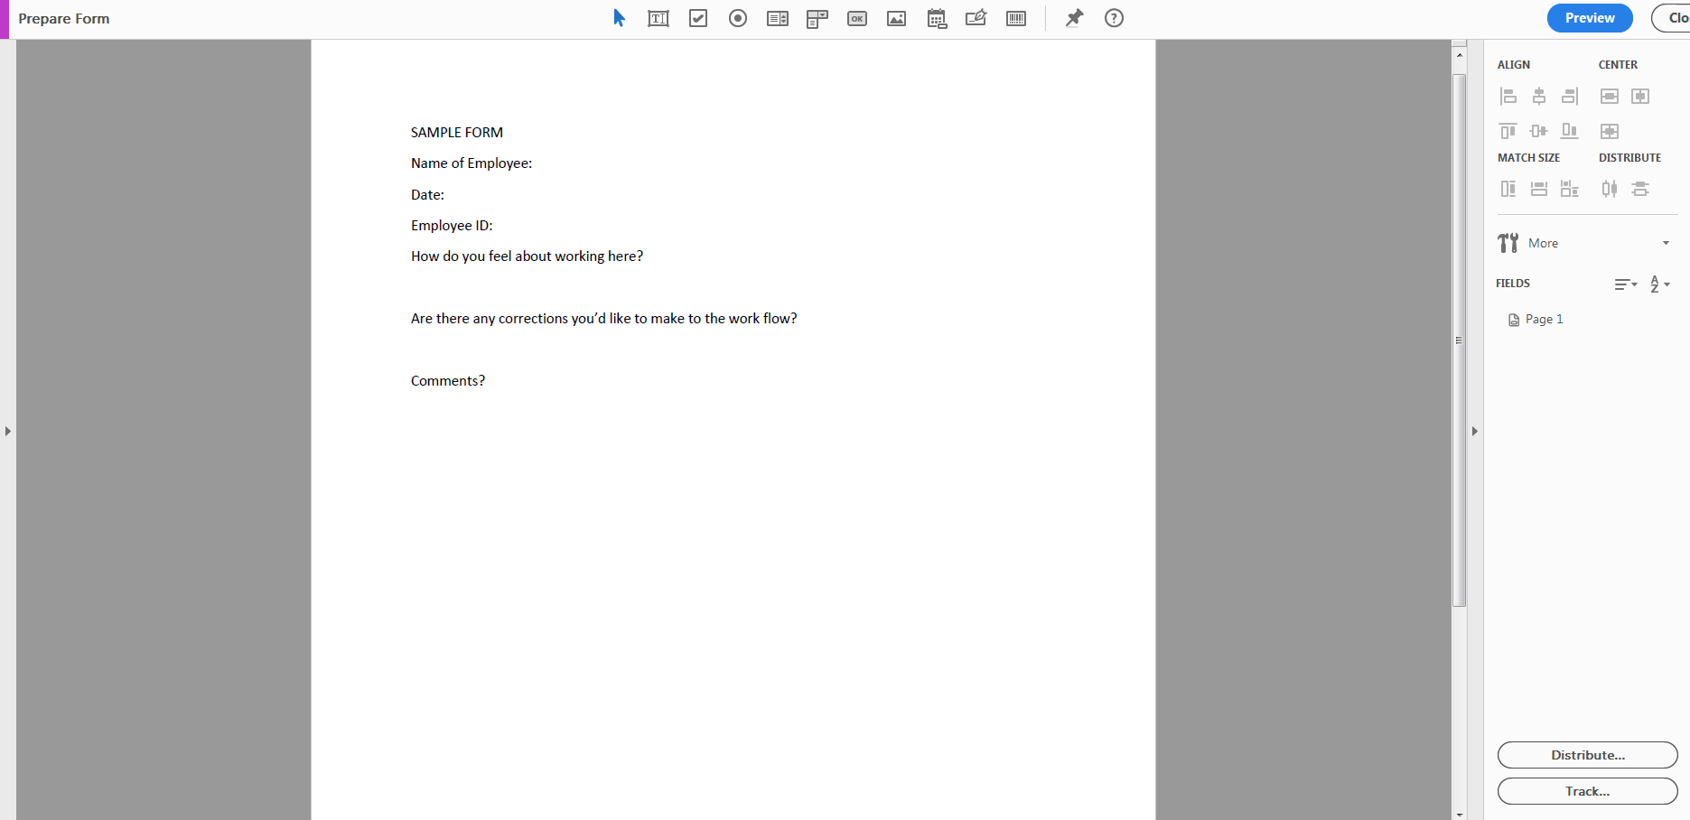

A sample form was created on Word, create your own form or find a sample one online!

1. Add new form fields from the top toolbar, and adjust the layout using tools in the right pane.

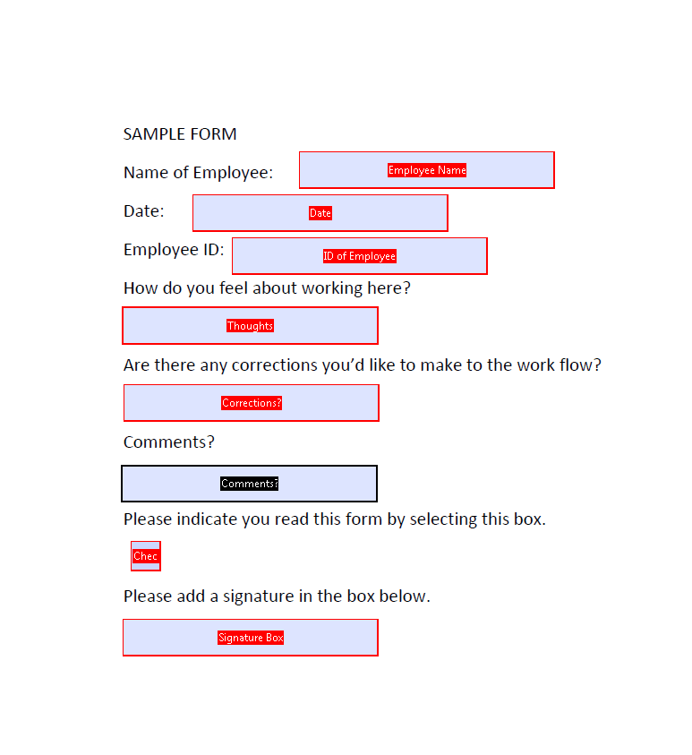

1. Add to your sample text: Text Fields (mandatory and not mandatory), a signature pane, radio buttons and check boxes.
2. Save your fillable PDF form and share it with at least one coworker to fill out or click Distribute to collect responses automatically.